Briefing Paper: Land South Of Coldhams Lane
- Planning Portal: https://applications.greatercambridgeplanning.org/online-applications/caseDetails.do?action=dispatch&keyVal=S4Y51ODXI3500&caseType=Application

- Planning Reference: 23/04590/OUT

- Applicant / Developer: BGO Newton Propco Limited

- Environmental Consultant: Ramboll

Plans
The map extract below is taken from the Master Plan. It shows the different parcels of land and the area that this development covers.
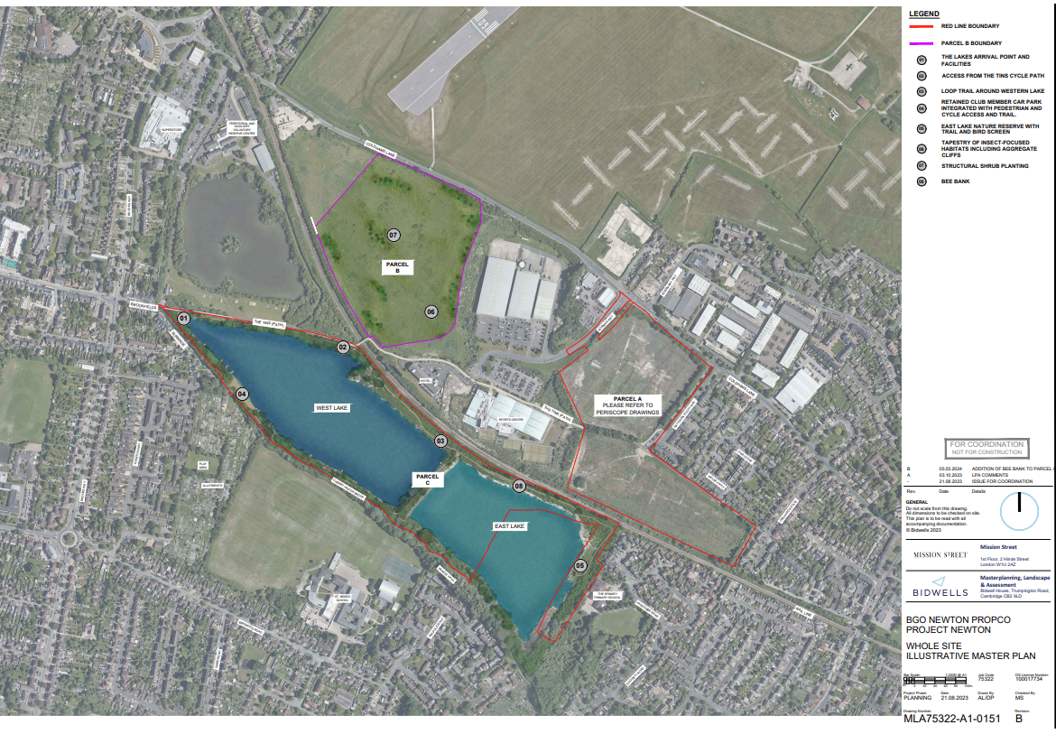
- Parcel A is a former landfill filled with a mix of different types of waste, ranging from non-reactive, to rotting, and hazardous materials. Many investigations have been done on this site over the years. It's well known that the waste here is a complex and highly variable mix of contaminated materials. The developer is proposing to build a science park here.
- Parcel B is a former landfill. There are no proposals to develop this land.
- Parcel C has groundwater fed lakes within former chalk quarry pits. The developer is proposing to open up this area for recreational use.
Local Environment
Parcel A and Parcel B are located on former landfills which have waste that is up to 16 metres deep in some places. Under the waste is a groundwater chalk aquifer. The landfills do not have an engineered liner at the bottom which means that contaminants leaching from them are polluting the underlying groundwater, the quarry lakes on Parcel C, and Cherry Hinton Brook. Cherry Hinton Brook is fed by the chalk aquifer.
Nearby drainage is leaking contaminated water, including hazardous substances, into the quarry lakes. The chemicals in this water match those typically found in landfill runoff (leachate). This discharge has been recognised as a source of pollution for the quarry lakes, one of which overflows into Cherry Hinton Brook.
Chemical testing of water in the former quarry pits, Cherry Hinton Brook, and the chalk groundwater has found several contaminants exceeding safe levels. These include hazardous substances such as per- and polyfluoroalkyl substances (PFAS), hydrocarbons, vinyl chloride, phenol, and heavy metals including chromium VI and mercury.
A recent risk assessment, undertaken by Ramboll, shows that most of the Parcel A site has low to moderate gas risks. Previous assessments had found local areas with higher gas risks, especially in the north-west and near the southern boundary. A gas risk from a landfill refers to the danger posed by gases produced as waste breaks down. These gases, like methane, can build up and potentially cause explosions or fires, and they can also be harmful if inhaled by people living or working nearby.
Note: A hazardous substance is any material that can pollute or damage water sources, making the water unsafe for drinking, agriculture, or other uses.

Key Documents
- Remediation Strategy Report, dated March 2024
The Remediation Strategy focuses on Parcel A, the old landfill which covers about 9.5 hectares (ha) and is currently undeveloped land with vegetation.
There’s still a potential risk of methane moving towards nearby properties, so further monitoring will be done around the site’s edge. Detailed plans for gas mitigation will be provided.
The planned large earthworks will disturb the waste in the landfills which could create dust, smells, and vapours. Plans for managing dust and odours will be provided.
The proposal to clean up the groundwater in Parcel A is to use a pump-and-treat method, along with installing a barrier to block water flow at the bottom of the landfill. This solution involves pumping water from the Chalk aquifer. The water will be collected from several wells, treated at a central wastewater plant, and then discharged into the sewer system with Anglian Water’s approval.
The construction work might spread contaminants, so they would need to sample and test the groundwater and nearby water before, during and after the development is completed. It is unclear for how long the pump-and-treat would need to occur to make sure that the environment is kept safe from contaminants due to the development.
- Environment Agency letter to the Local Planning Authority (LPA), dated 24 May 2024
In this letter, the Environment Agency (EA) maintains their objection to the development citing that the risks that it presents to the water environment are unacceptable. The EA highlights that the landfill waste at the site is already polluting the chalk aquifer and nearby water and the current plans to fix this don't seem effective. They don't believe there is a workable solution to manage the pollution risks. The EA are also concerned that the proposed construction methods could pollute nearby water, and the current information doesn't show that these risks are well understood or can be properly managed. They don't believe the development can proceed without causing more water pollution. The EA’s comments on the Remediation Strategy include the following:
“The technical information submitted to date does not demonstrate that the remediation strategies considered feasible will adequately manage this pollution. We do not have confidence that there is a viable remediation strategy to manage the existing pollution risks to controlled waters”.
Furthermore the EA discusses the limitations of the pump-and -treat approach. If the developer wishes to pump out leachate or groundwater from this area, they will need a special environmental permit. The permit will only be given if the water is returned to the environment in some way and doesn’t harm it. The EA are not convinced that this site meets these rules because the developer intends to send the pumped water into the sewer system which goes against the rule that the water must be returned to the environment. The EA warns the developer that obtaining an environmental permit or a water-pumping licence isn’t guaranteed.

- Outline Foundation Risk Assessment Report, dated July 2024
The environmental consultant (Ramboll) prepared this report in response to the EA’s letter (above). In the document they assess options for building foundations and other landscaped areas (ground improvement works) whilst finding a way forward that minimises the risk of polluting the chalk aquifer beneath the landfill site and the wider water environment. It is not clear in the report how environmental risks from the construction works will be managed.
The report also states that “no remediation actions have been identified as being required for Parcel C”. Given that the plans are to open up Parcel C to the public, this raises the questions:
- Will the public be made aware of the unsafe water quality of the quarry lakes?
- Will the LPA ask for the Remediation Strategy to include the quarry lakes?
The EA are yet to comment on these latest proposals.

- LPA and EA Presentation Doc (Rev 01), dated 09 July 2024
The “LPA and EA Presentation” document was prepared by the developer in response to the EA’s letter to the LPA dated 24th May.
In this document, the developer suggests eight pre-commencement planning conditions and a route map for how to agree on these.
The developer believes that while more information and trials are needed, many of these trials need their own planning permission. To carry out these trials, the EA needs to lift their Objection, at least temporarily.
The developer proposes starting foundation trials at the site in the fourth quarter of 2024. If the developer is serious about what they are proposing in the Remediation Strategy (gas mitigation plan, dust and odour plan, pump-and-treat), these steps should surely be completed before any foundation trials can start?
The EA are yet to comment on the proposed pre-commencement planning conditions.

- Ground Contamination Update and Roadmap, dated 12 July 2024
In this memo, Ramboll supply a set of responses to the EA’s key comments and questions about the documents they have reviewed to date. They have also included a 'route map' that shows the planned foundation assessments, trials, and groundwater remediation tests needed to fully answer some of the EA’s questions. The EA are yet to comment on these latest proposals.
It is concerning that the developer is proposing to start trials at the site and yet Ramboll do not fully understand how the landfill leachate is managed. In Table 3, Ramboll acknowledge that they haven't figured out where the contamination in the leaky drainage is coming from. They mention that they need to work with Railway Pension Nominees Ltd ('RailPen'), who are believed to own the leachate collection system.
Since the leachate collection system is owned and operated by other parties, dealing with the issue is complicated when it comes to figuring out who's responsible. It is vital that these complex issues are resolved sooner rather than later.

- Environmental Health (Updated / Consolidated Position), dated 26 July 2024
In this letter to the LPA, the Environment Health Officer at Cambridge City Council states that they have serious concerns about the contaminated land. Until this issue is fully resolved to their satisfaction, they can't support the application. They recommend rejecting this application because there isn’t enough information about the contamination risks to water and future site users. They are worried about the ground conditions and how the construction work will be done. They need to know how building on this land will affect the area, including potential odour problems from disturbing the contaminated ground. They emphasise that the contamination risks (from soil and gas) are complex and very serious for future

- Environmental Agency’s Report: dated 9t^{h} August
The EA says that after conversations with the LPA, it would be ‘unreasonable and inappropriate to maintain our holding objective’.
However in the next sentence they indicate scepticism as to whether the scheme is technically deliverable and then issue 15 pages of strict conditions which they deem necessary to ensure this plan does not lead to further pollution of controlled waters in the chalk aquifer (source of drinking water) and risks to human and environmental health.
They are not satisfied with the draft conditions provided by the developer in mid July.
They, echoing the Environmental Health report, suggest that Section 106 monies be used to ensure proper monitoring and express doubt all the way through the document that this can be done safely.
‘We consider that the Developer will encounter serious and potentially insurmountable
technical challenges to delivery of the proposed scheme and to the management of the
associated pollution risks to controlled waters. We have drawn your attention to areas of
concern in our previous consultation responses. We re-iterate here that:
1) The Site is already causing pollution of controlled waters. We consider it has not
been demonstrated that there is a viable remediation strategy to adequately manage
this pollution;
2) The construction methods that are proposed on the Site pose a pollution risk to
controlled waters. We consider it has not been demonstrated that these risks can be
adequately managed;
3) Development on the Site as proposed is likely to require consents, abstraction
licences and environmental permits from the Environment Agency. We consider that
there is no guarantee that the necessary permissions will be granted.’
They consider similar landfill sites which have been developed, or are in planning for development and argue that each of these is less risky than the Coldham’s Lane site.
One big question is:
WHAT CHANGED BETWEEN A STRONG ARGUMENT FOR A HOLDING OBJECTION ON THE 24TH MAY 2024 AND THE DROPPING OF THE HOLDING OBJECTION ON THE 9TH AUGUST 2024. WHAT PRESSURE DID THE EA SUCCOMB TO?
THERE SEEMS TO BE NO NEW SCIENTIFIC EVIDENCE CAUSING THEM TO CHANGE THEIR MINDS.
And given the extensive monitoring needed to ensure the development does not lead to unacceptable risk, IS THIS THE BEST USE OF PUBLIC MONEY, OR INDEED OF PUBLIC AND 106 MONEY (AS PROPOSED)? DOES THE EA HAVE THE CAPACITY TO MAINTAIN A WATCHING BRIEF AT THIS LEVEL?
Finally, given that dropping the objection makes it much more likely the Council will approve a pre-building trial period, what assurances can the Council give the public that these trials will be transparent, and the results open to public scrutiny? And for how long will the careful monitoring go on?

